POSTAL INFORMATION FOR HMC SHIPS ON DEPLOYMENT

GENERAL

- Your mailing address will be one of the following, depending on where your military member is deployed:

RANK / NAME / INITIAL  HMCS (SHIP’S NAME), MESS #  PO BOX 17000 STN FORCES  VICTORIA, BC  V9A 7N2 | RANK / NAME / INITIAL  HMCS (SHIP’S NAME), MESS #  PO BOX 99000, STN FORCES  HALIFAX, NS  B3K 5X5

- The Naden Mail Office and the Fleet Mail Office (FMO) offer full Canada Post services. All letters and parcels can be mailed from these locations or from any Canada Post outlet.

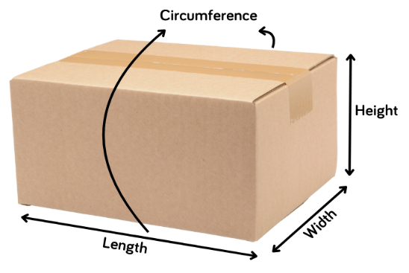
- Size: Maximum dimensions for a parcel are as follows:
Maximum length of one side: 1m
Maximum size: Height + Width + Height + Width = Circumference
Circumference + Length = <2m
Maximum Weight: 20kg

- All mail from the ships will be routed via international airmail back to Canada, where it will be Customs cleared prior to entering the Canadian mail stream.

WHEN POSTAGE IS NOT REQUIRED

- For personnel on deployed HMC Ships, the Canadian Forces provides a “free” mail service. This service allows personal mail, consisting of parcels and letters, from families, to be sent to service members on operational deployments.

- The following important points are to be noted:
  - The maximum weight for parcels is 20 kilograms;
  - The CF and FMO are NOT responsible for any loss, theft or damage caused to items sent via this service. As there is no postage affixed to the items, no claim can be made through Canada Post;
  - Return mail service for undeliverable mail without affixed postage will not be provided therefore, proper addressing is important;
  - The sender must place their name, address and phone number on the top left corner of the parcel. This enables FMO to contact them should a problem arise. A complete list of the items enclosed in the package must also be clearly written on the outside of the parcel;
  - Mail may be dropped off at the Naden Mail Office building N34 (Basement of Nelles Block) at CFB Esquimalt, Fleet Mail Office building D37 in Dockyard, or either of the MFRC locations: Signal Hill (1505 Esquimalt Rd) or the MFRC at CPAC (2610 Rosebank Rd). Please remember, if you mail your items from any other Canada Post outlet you will be required to pay postage;
  - If you wish to register the mail or purchase insurance, postage is required.

Note: A Customs Declaration form must be filled out for all parcels. These are available at the Post office, CPAC, Signal Hill or the Base Mail Office, just ask for this form.(43-074-172)
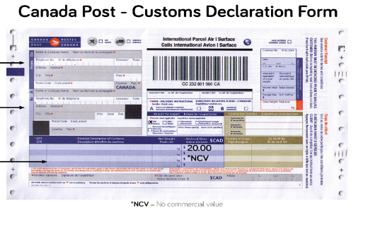

PROHIBITED ARTICLES

The following articles are prohibited in morale mail and are likely to be rejected by the Fleet Mail Office:
- Weapons, (including knives) or replica weapons
- Obscene material including magazines or pictures
- Dangerous goods as defined by Transport Canada’s Transportation of Dangerous Goods Regulations
- Compressed gas, (i.e. aerosol cans such as shaving cream, air fresheners, etc.)
- Corrosive fluids (i.e. bleach, acids, ammonia)
- Flammable liquids or solids (matches, lighters, many perfumes and toiletries have an alcohol base which is flammable)
- Explosives, radioactive materials or ammunition including inert ammunition
- Lithium batteries or anything that might contain a lithium battery: E-cigarettes, headphones, power banks, cell phones or cell phone batteries
- Alcohol (beer, cider, coolers, wine, etc.)
- Tobacco products (Cigarettes, Cigars, Cigarillos, Chewing Tobacco, Loose Tobacco, etc.)
- Electronic Smoking Products (E-Cigarettes, Cigars, Cigarillos, Pipes and Liquid Cartridges, etc.)
- Cannabis or any product containing Cannabis
- Drugs or other controlled substances including narcotics (prescription drugs)
- Perishable items (Fruit, Vegetable, Meat, etc.)
- Plants, Seeds, Fruit, Bark, Plant Parts or Soil
- Animals
- Hand Sanitizer – alcohol based thus flammable
- Anything that might soil or damage the mail, including canned goods, sauces, maple syrup, and freezies
- Liquids of any kind
- Humanitarian aid/charitable goods are not to be sent through the Morale Mail system.

The above is not a complete list. If you are unsure about a particular item or have further questions about prohibited items, please contact the Fleet Mail Office at 250-363-2176.

Criminal Code and Other Offences

Any person using the mail for the delivery of any one of the following items commits an offence:
- Articles that are obscene, indecent, immoral or scurrilous.
- Any information relating to bookmaking, pool-setting, betting or wagering.
- Articles relating to unlawful lottery schemes.
- Any article relating to schemes to deceive or defraud the public.
- Articles or special messages sent to any person with the intention to obtain money under false pretenses.

