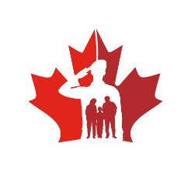
CHAIRING BILINGUAL MEETINGS CheckList
In accordance with the Official Languages Act, the following practices apply to any meeting held in a designated bilingual region for language-of-work purposes, or where participants belong to both linguistic groups:
Checklist:
☐ Invitation is sent in both official languages;
☐ Agenda and other reference documents are provided in both official languages;
☐ Participants are greeted in both official languages;
☐ Everyone is encouraged to use the language of their choice;
☐ Alternate between English and French;
☐ Questions are answered in the official language in which they were asked;
☐ Summaries are provided, as needed, in the alternate official language;
☐ Participants are encouraged to ask for clarification when needed;
☐ All ideas are given equal weight, whether voiced in English or in French;
☐ Colleagues are asked to co-chair bilingual meetings to ensure the balanced use of both official languages;
☐ The bilingual nature of meeting is maintained even in the presence of unilingual participants (remember that the presence of unilingual participants does not preclude bilingual meetings);
☐ Feedback is requested from participants on the use of both official languages during the meeting; and
☐ Minutes are distributed simultaneously in both official languages. Where the recipients of the minutes are known to be bilingual, you can choose to alternate between the languages, as per the suggestions below:
☐ The minutes of a single meeting written partly in English and partly in French; or
☐ The minutes written entirely in English one time and entirely in French the next time, in the case of a series of meetings.

