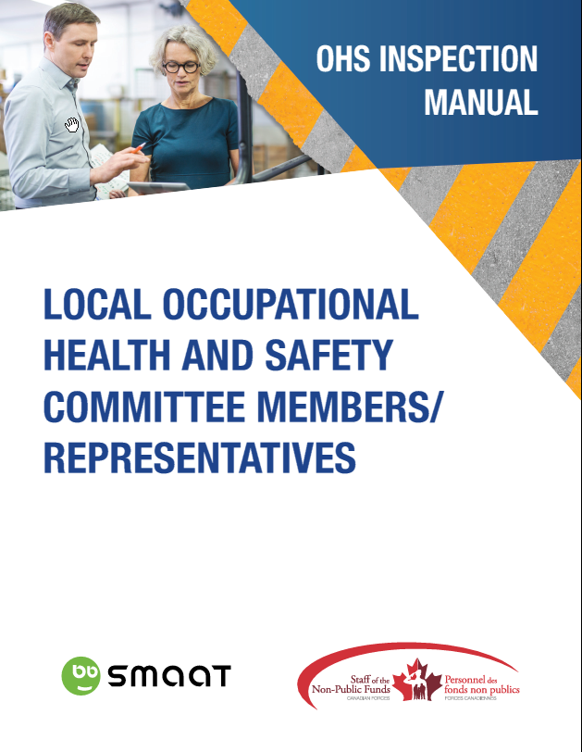

Inspection Manual
for Local OHS Committees/Representatives

Contents
Introduction 3
References 3
Definitions 3
Timeframes 3
People involved 3
What to inspect 4
Tools 4
Steps of an inspection 5
Preparing 5
Inspecting 5
Following up 5
Best practices for inspectors 5
Guide for possible answers to provide employees when concerns are raised with inspectors 6
1. Ergonomics 6
2. Thermal comfort in the office 6
3. Workstation 7
4. Parking lot/ Pathways 7
SMAAT – Process to record an inspection 7
LOCAL OHS COMMITTEE/REPRESENTATIVE INSPECTION FORM 12
Inspector’s notes 12
Quick Reference Card – Generic 13
Quick Reference Card – Generic 14
Quick Reference Card – Outdoor 15
Quick Reference Card – First Aid Kit 16

Introduction
The monthly occupational health and safety inspection is a fact-finding exercise, with the aim of preventing accidents and incidents from happening. Inspectors and employees need to well understand the goal of the inspection at the workplace to encourage the maximum exchange of information.

The employer may conduct additional inspections considering the following points:

- the number and scale of the processes, operations or tasks;
- hazardous equipment requiring inspections at fixed intervals;
- processes that pose a significant hazard, requiring separate and more frequent inspections;
- the number of shifts, because work activities may vary from one shift to another; and/or
- introduction of a new process or new machine in the workplace, requiring a special inspection.

References
Canada Labour Code Part II, section 125. (1) (z.12), section 135. (7) (k), and section 136. (5) (j)
HRPOL13, Parag. 13.21 to 13.26 – OHS Prevention Program

Definitions
OHS: Occupational Health and Safety
LOHSC: Local Health and Safety Committee
LOHSR: Local Health and Safety Representative
DND/CAF: Department of National Defence/Canadian Forces
SLER: Senior Local Employer Representative

Timeframes
Every building must be inspected monthly in its entirety (12 times per year).
- Perform inspection a week prior to the Local OHS committee meeting in order to discuss pressing issues. If no meeting is scheduled, please proceed a month after the previous inspection.
- Record a proof of inspection and the observations / findings / recommended actions in SMAAT within a day of the inspection.
- Expect a response to all inspection tickets within 30 days of their creation.

People involved
Role | 20 employees or more | Less than 20 employees
Inspector | Local OHS Committee Members (team of 2: employee representative and management representative) | Local OHS Representative (may team up with a manager on the floor)
Reviewer | Local OHS Committee Co-chairs | Local OHS Representative
Manager | Senior Local Employer Representative (SLER) | Senior Local Employer Representative (SLER)

What to inspect
The LOHSC/LOHSR shall conduct a visual inspection of all workplaces monthly. Areas that are not generally used as workplaces, such as parking facilities, cafeterias and locker rooms should also be inspected.

General : Observe for housekeeping, emergency equipment and fire hazard.

Look in:
- Work area, office and cubicle area
- Storage rooms, restricted access rooms
- Common areas such as meeting rooms, reception, entrance, stairwells, aisles, lunchroom, washrooms/showers

Personal Protective Equipment (PPE). Observe for operating errors in the use of personal protective equipment provided to protect :
- Eyes and face
- Ear
- Hands and arms
- Feet and legs
- Respiratory system or vital organs

Look for:
- Failure to use
- Improperly fitted or adjusted
- Unqualified or not trained in use
- Failure to properly maintain
- Use of damaged equipment, etc.

Equipment and Tools.

Look for:
- Use of incorrect tools for the task
- Use of unsafe or improperly maintained tools Incorrect use of tools
- Abuse of tools
- Unqualified or unauthorized person using tools or equipment.

Procedures and Orderliness.

Look for:
- Use of incorrect procedures for the task
- Unqualified or unauthorized person
- Avoiding proper application of procedures
- Sub-standard of orderliness (housekeeping).

Security measures: First aid kit and first aid station

Tools
Inspector’s notes: see page 12
Quick Reference Cards: see page 13-16
Link to SMAAT is available at http://cfmws.com/OHS under OHS Representatives & Legislation

Steps of an inspection

Preparing
- Schedule the inspection in advance.
- To facilitate the inspection of a large building, share the task and map out the location of the following:
  - Safety bulletin board(s)
  - Portable fire extinguishers
  - First aid stations
  - Sections
- Find the inspection quick reference card that best suit the workplace you are planning to inspect.
- Review previous month’s inspection observations / findings / recommended actions and actions taken.
- If areas are restricted or you are not familiar with it, make an appointment with the person responsible.
- Sometimes, other groups perform inspections (e.g. fire wardens, first aid kit provider). You might team up to avoid duplication.

Inspecting
- Inspectors perform visual inspection and write down observations / findings / recommended actions. They may use photographs where possible and feasible for problem areas as they provide positive proof and greatly reduce report writing.
- Inspectors record within a day of the inspection using the SMAAT web based software:
  - proof of inspection
  - observations / findings / recommended actions
- The co-chairs review the tickets and modify the information, if required. They discuss during regular committee meeting any outstanding tickets.
- The SLERs review the tickets and take action within their delegated authority to resolve items (Tickets). They may have to consult, work with, delegate to others or escalate according to the chain of command. An item may take more than one step to resolve. It is best to record progress as it occurs.

Following up
- Local OHS Committee Co-chairs/ Representatives raise to SLER’s attention any pending/unresolved tickets.

Best practices for inspectors
- When OHS committee members are walking around inspecting or observing the environment, some employees might wonder what’s going on. It is good practice, to introduce yourself as a member of the local OHS committee/ representative. Explain that you are performing the monthly inspection of the workplace with the aim of preventing accidents and incidents from happening.
- When employees raise a safety concern to your attention, take the time to listen. Ensure that they have first discussed the concern with their manager. Take note on the form. Please refer to Guide for possible answers to provide employees when concerns are raised with inspectors below.
- People in the workplace may hear the inspectors discuss issues during inspections, but we want them to hear positive feedback as well. (e.g. this section is well maintained)
- Be specific about the information you record (observations / findings / recommended actions) as it is likely to be passed to management for decision and action.

Guide for possible answers to provide employees when concerns are raised with inspectors

1. Ergonomics

Employees should discuss concerns with their manager first as they might be able to try out solutions that are available to them.
1.1 If an employee has an existing medical condition, HRPOL section 15 – Employment Accommodation should be used.
1.2 If an employee experiences discomfort at their workstation, HRPOL section 13 – Safety - Ergonomic Program should be used.
- Employees should read the DND/CAF Guide to Office Ergonomics and adjust their workstation, to the best of their ability. It is understood that there are some limitations to the adjustments the employee can make;
- Ergonomic assessment can be performed by a third party when the employee completes the form and the director approves it;
- The division is responsible to implement the third party recommendations in a timely manner. The employee is responsible to adopt the third party recommendations.

Finally, the local HR Office can help with employment accommodation and ergonomic assessment.

2. Thermal comfort in the office

The federal legislation doesn’t provide a single value for the maximum/minimum temperature to which you can be exposed while working in an office environment.
The CSA Standard CAN/CSA Z412-00 (R2011) - "Office Ergonomics" gives acceptable ranges of temperature and relative humidity for offices in Canada. The recommended temperature ranges (see below) have been found to meet the needs of at least 80% of individuals.
Standards on office temperatures
Note: Some people may feel uncomfortable even if these values are met.

Temperature / Humidity Ranges for Comfort
Conditions | Relative Humidity | Acceptable Operating Temperatures
 |  | ºC | ºF
Summer (light clothing) | If 30%, then  If 60%, then | 24.5 – 28  23 – 25.5 | 76 – 82  74 – 78
Winter (warm clothing) | If 30%, then  If 60%, then | 20.5 – 25.5  20 – 24 | 69 – 78  68 – 75
Source: Adapted from ASHRAE 55-2010.

Facility management aims to keep the workplace temperature in the middle of the range, but sudden change in weather, locations near windows, doors, vents, and occupancy are all factors that influence thermal comfort.

3. Workstation

Employees are responsible to maintain their workstation clean. The cleaning staff vacuums the floor and dusts the top of the cubicle separators. They are not allowed to move items in cubicles. Employees who encounter an issue with the furniture or office accessories (lighting, furniture that needs to be moved, etc.) should discuss it with their manager/supervisor.

4. Parking lot/ Pathways

The employer is responsible for taking all reasonable precautions to prevent injuries or accidents in the workplace. What is considered reasonable? The usual clearing, salting and applying of abrasives is the reasonable standard. A good practice when gauging what is a reasonable precaution is to compare it with a similar situation. For example, when it comes to snow or ice accumulation, one could compare the clear up with commercial buildings and roads around. A small patch of ice or a pothole in a pedestrian area can be marked with a sign similar to wet floor in the office.

However, if there is a snowstorm, the parking lot might be less than ideal. The employee also has the responsibility to exercise reasonable caution to ensure his or her own safety (change the way one walks, wear appropriate footwear, ask for help etc…

SMAAT – Process to record an inspection
Important:
- Keep proof of mandatory monthly inspection in SMAAT by creating one ticket and entering it under Type of risk as “1-proof of inspection”
- Record each issue noted during the inspection separately. 1 issue = 1 ticket

Access SMAAT at http://cfmws.com/OHS under OHS Representatives & Legislation

- Click on Inspection

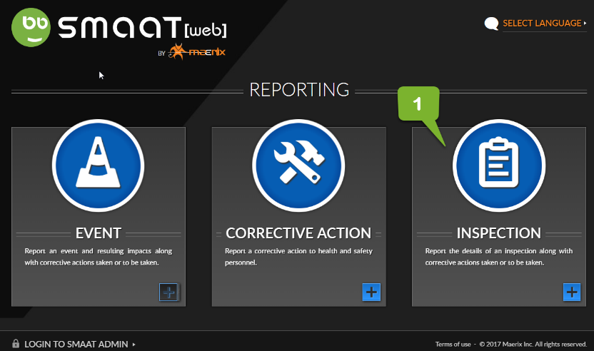
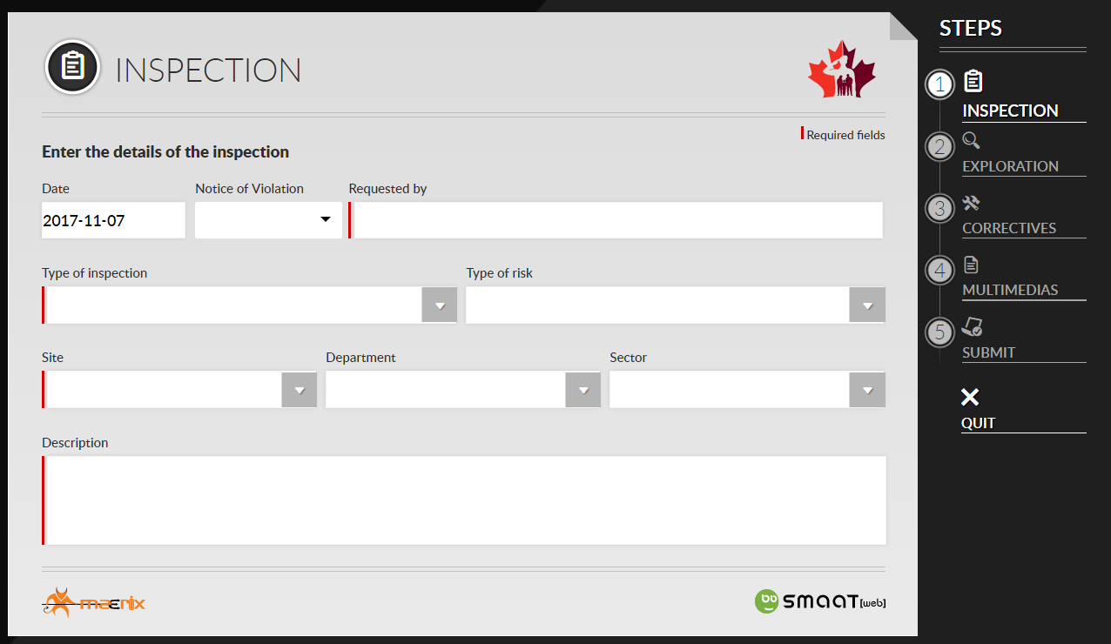
STEP 1 – INSPECTION
- Date: Date of inspection
- Notice of Violation: “no” is selected unless an Employment and Social Development Canada OHS Officer is involved.
- Requested by: enter the name of your SLER
- Type of inspection: select Local OHS committee
- Type of risk: Biological hazard, Chemical hazard, Ergonomics hazard, Physical hazard, Psychosocial hazard, Safety hazard. For more info, table below
- Site / Department / Sector: Select as appropriate
- Description: Be specific when providing a description of the observation, finding or recommendation. Include the hazard and safety issue. (e.g. torn carpet in the middle of high traffic hallway represents a risk of slips, trips and same-level falls)

Type of risks | Description
Biological hazard | Microscopic organisms such as bacteria, viruses, or fungi transmitted by insects, plants, birds, animals, or humans.
Chemical hazard | Liquid, gases, or solids substance that can be inhaled, swallowed, injected or absorbed through the skin
Ergonomics hazard | Lifting, pushing, pulling ; sitting / standing ; lighting
Physical hazard (molecular level) | Extreme temperature, radiation, vibration
Psychosocial hazard | Stress, bullying, violence, working alone, shift work
Safety hazard | Slips, trips and falls;  Ladders / platforms, tools, confine spaces, machinery, traffic

- Site / Department / Sector: Be as specific as possible
- Description: Be specific when providing a description of the observation, finding or recommendation. Include the hazard and safety issue. (e.g. torn carpet in the middle of high traffic hallway represents a risk of slips, trips and same-level falls)
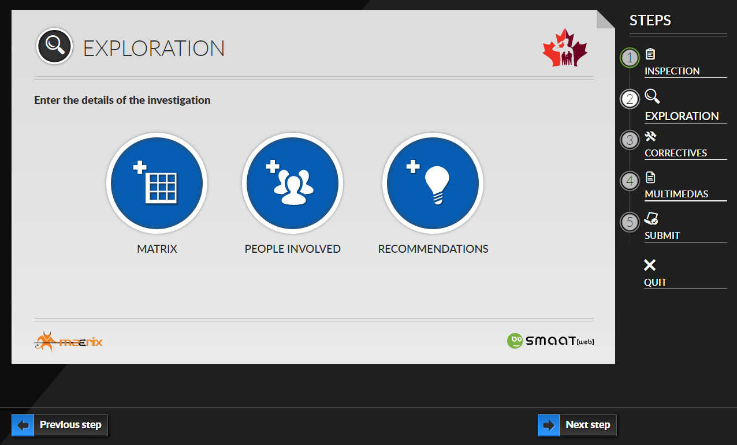

STEP 2 – EXPLORATION
Matrix: Select to the best of your knowledge the appropriate box for “Individual” and “Environment”. Roll over "levels of risk" to preview the definitions.
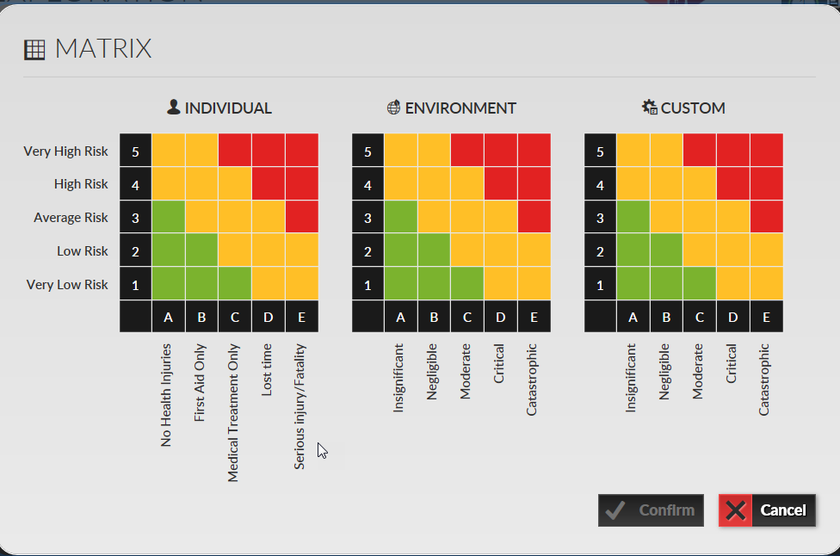

- No health injuries:
- First aid: First aid is the assistance we give an injured person on site to help protect their life and prevent further injury.
- Medical Treatment Only: Medical treatment is provided by a health care professional at a hospital, medical clinic or physician’s office and is not to be confused with first aid.
- Lost time: Lost time occurs when an employee sustains a work-related injury, which results in lost time from work after the day of the incident.
- Serious injury/Fatality: Permanent disabling injury (e.g. amputations, multiple injuries, fatal injuries, occupational cancer)
- Very low risk: less than 1% of being experienced by an individual during their working lifetime
- Low risk: typically experienced once by an individual during their working lifetime
- Average risk: typically experienced once every five years by an individual
- High risk: typically experienced once or twice a year by an individual
- Super high risk: typically experienced once a month by an individual

- People involved: Enter the name of the inspectors

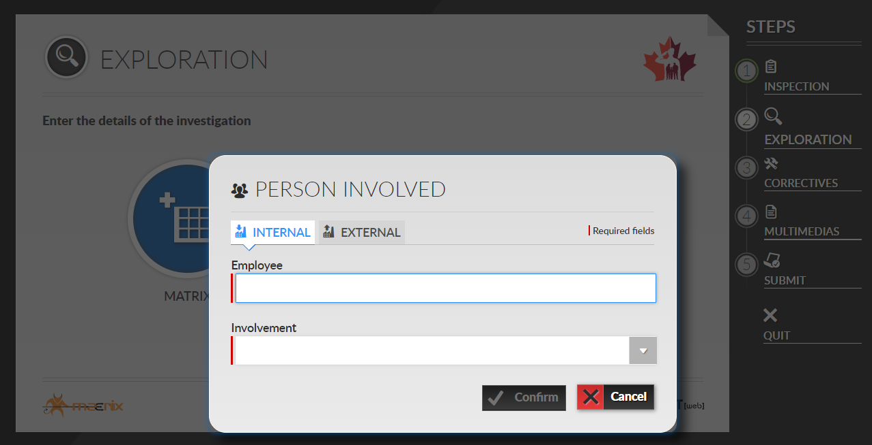

- Recommendations: Use the text field to enter your recommendations

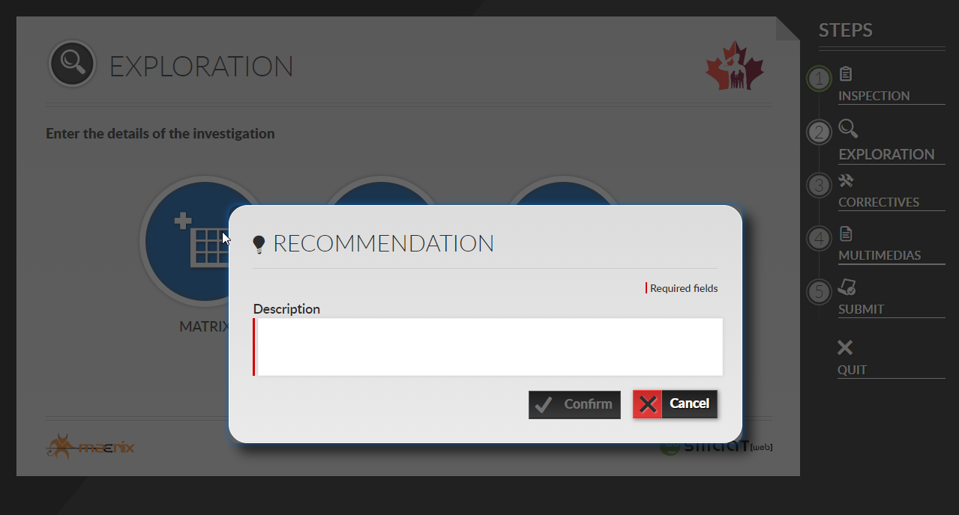
STEP 3 – CORRECTIVES
- Usually the inspector will not be the action taker.

STEP 4 – MULTIMEDIAS
- Attached photos, video or documents pertaining to the issue, as necessary.
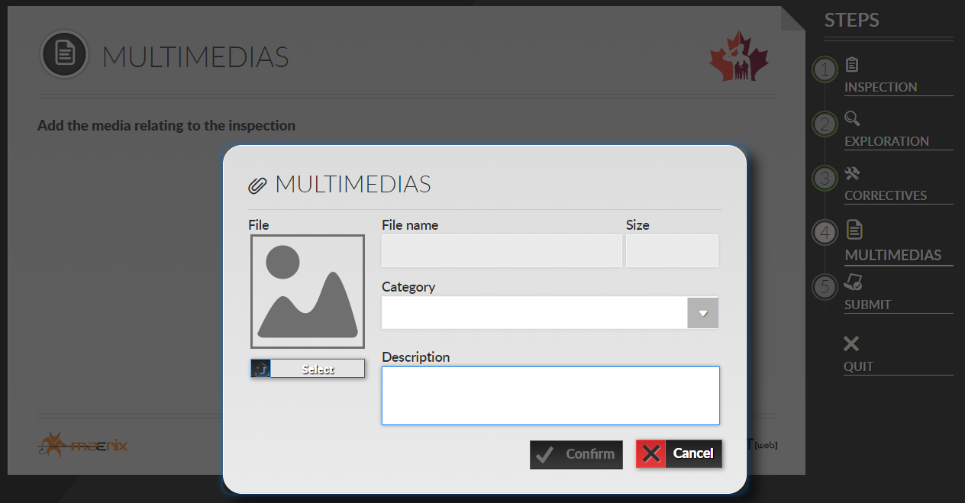
STEP 5 – SUBMIT

LOCAL OHS COMMITTEE/REPRESENTATIVE INSPECTION FORM

Inspector’s notes
Record observations / findings / recommended actions within a day of the inspection using the SMAAT web based software at http://cfmws.com/OHS under OHS Representatives & Legislation

Date of inspection: Area inspected: Name:

Observations / Findings / Recommended Actions

Name of employees you provided guidance with short explanation

Quick Reference Card – Generic
Visual inspection of the workplace by the Local OHS committee / representative performed monthly (12 times per year)

Safety Bulletin Board | Housekeeping
Every workplace shall have a safety bulletin board accessible to every employee and include:  ☐ LOHSC Members or LOHSR: Name, phone number and location  ☐ Employer’s statement covering OHS policy  ☐ Canada Labour Code Part II and Regulations  ☐ NPF OHS Policy (HRPOL section 13)  ☐ Building Fire and Emergency Plan  ☐ Fire Wardens: Name, phone number and location  ☐ Location First Aid Kits and Automated External Defibrillator (AED)  ☐ First Aid Attendants: Name, phone number and location  ☐ WHMIS Information  ☐ Material Safety Data Sheet (MSDS) or (SDS) less than 3 years old  Required where 20 or more employees are working at any time in a workplace.  ☐ Minutes of last OHS Committee Meeting, if applicable  ☐ ESDC Annual OHS Committee Report, if applicable | ☐ Slip (e.g. liquid) and trip hazard (e.g. filing stool, wastebasket, extension cords)  ☐ Lighting: insufficient, dark areas  ☐ Ceiling: light diffuser or tile missing  ☐ Floor: loose material, debris, worn carpeting, broken tile  ☐ Furniture or equipment: worn, broken, sharp edges.  ☐ Material: Stored safely, neatly and safely piled  ☐ Filing cabinets: Drawer kept closed when not in use  ☐ Shelves: overloaded, beyond rated capacity, larger and heavy objects stored on lower shelves  ☐ Equipment/ Space over crowded  ☐ Overhead hazards  ☐ Stepladder or stool: adequate to reach overhead storage
 | Fire hazard
☐ Heating and air conditioning vents: objects covering, accumulation of dust
☐ Combustibles near heating source
Emergency Equipment | Sanitation
Portable fire extinguishers  ☐ Identified by a conspicuous sign  ☐ Available and accessible  ☐ Hangers for the extinguishers firmly attached to the wall  ☐ Inspection tag attached to the fire extinguisher initialed within the past month  Fire alarm pull stations  ☐ Accessible  Sprinkler system and associated piping  ☐ Free of any decorations or attachments  ☐ At least 18” clearance between sprinkler heads and storage  Emergency exits  Some exit doors are connected to an alarm system. Please DO NOT open the door unless the alarm is turned off. An alternative to opening the door is to go around the building to ensure nothing prevents the door from opening.  ☐ Free of obstructions  ☐ Exit sign lit  Fire-rated door, if any  Fire-rated doors are marked with a plate near a hinge  ☐ Free of obstructions  ☐ Kept closed | ☐ Refrigerator and microwave  ☐ Counter tops and sink  ☐ Tables  ☐ Garbage containers (with lid in food preparation area)  ☐ Toilet  ☐ Shower  ☐ Drinking fountain  ☐ No presence of insects or rodents
 | Electrical Safety
☐ Electrical outlets free of overloads
☐ Electrical cords in good condition
☐ Electrical cords used temporarily
☐ Only small appliances in authorized areas
☐ Area around electrical panels and breakers free of obstructions
Emergency Preparedness | Tools
☐ Floor plan with evacuation routes identified and posted - “You are Here” indication must appear  ☐ Emergency procedures (evacuation, fire, bomb threat, hostile person) posted  ☐ List of the hazardous substances used, produced, handled, or stored for use in the workplace.  Hazardous substance: includes a controlled product and a chemical, biological or physical agent that, by reason of a property that the agent possesses, is hazardous to the safety or health of a person exposed to it. | ☐ Ladders and climbing devices: condition, storage and proper use.  ☐ Hand tools: any defects, general conditions, storage and proper use.  ☐ Power tools: condition and guarding.  ☐ Machine guarding: nip points, cutting and shear edges, presses, rotating parts and gear device.

Quick Reference Card – Generic

First Aid | Hazardous Substances
First aid Kit  ☐ Proper first aid kit for number of employees and work environment  ☐ First aid kit supplies complete as per First Aid kit content checklist  First aid stations:  ☐ Identified by a conspicuous sign  ☐ Names, numbers and location of First Aid Attendants  First aid room:  Required where 200 or more employees are working at any time in a workplace.  ☐ Identified by a conspicuous sign  ☐ Under the supervision of a first aid attendant  ☐ Names, numbers and location First Aid Attendants  ☐ Phone number to reach emergency services  ☐ Telephone  ☐ Moisture-protected mattress and moisture-protected pillows clean and tidy | Products  ☐ Supplier label appears on original products  ☐ Workplace label appears on:  - a hazardous product is produced (made) at the workplace and used in that workplace  - a hazardous product is decanted (e.g., transferred or poured) into another container  - a supplier label becomes lost or illegible (unreadable).  ☐ Any new hazardous products introduced in the workplace since the last inspection  ☐ Compressed gas cylinders stored according to manufacturer’s instructions  MSDS or SDS  ☐ available to every employee  ☐ available to Emergency Response Personnel  ☐ available for all hazardous substances  ☐ up to date (date of last revision appears in SDS Section 16 – Other Information)
Public Access Automated External Defibrillator (AED) | Spill Response
☐ Status indicator (e.g. Illuminated check mark indicates the unit passed its last self-test and is ready for use / Illuminated “X” indicates unit has failed its self-test and is not ready for use.)  ☐ Instructions available for the use of the AED in both of Canada’s official languages  ☐ Designated person responsible for inspecting the device  ☐ Signed and dated record of inspection available | ☐ Emergency spill response procedures written and clearly posted in the work area  ☐ Absorbent materials available for immediate containment of spills or leaks  ☐ Available, accessible and sufficient quantity of absorbent material, equipment and PPE.
Personal Protective Equipment (PPE) | Emergency Showers and Eyewash Stations
☐ Work areas where PPE must be worn are identified by a conspicuous sign  Disposable Protective Equipment  ☐ Available and accessible  ☐ Sufficient quantity  Shared Protective Equipment  ☐ Available and accessible  ☐ Cleaned and well-maintained  ☐ Store in clean dry air - free from exposure to sunlight or contaminants  Personal Protective Equipment  It is the employees’ responsibility to:  - Follow manufacturer's instructions  - Inspect PPE before and after each use.  - Take care of PPE at all times.  - Clean all PPE after use.  - Store in clean dry air - free from exposure to sunlight or contaminants  - Ask their supervisor to repair or replace damaged or broken PPE | ☐ Identified by a conspicuous sign  ☐ Accessible  Plumbed Emergency Showers and Eyewash Stations  ☐ Clean  ☐ Designated person responsible for inspecting and operating (activating) devices weekly  ☐ Signed and dated record of inspection available  Portable, Self-Contained Eyewash Stations  ☐ Clean  ☐ Self-contained systems are fully charged  ☐ Shelf life of the solution not expired  Eyewash Bottles  ☐ Supplement plumbed and self-contained stations  ☐ Expiry date of the fluid printed on the bottle  ☐ Shelf life of the solution not expired

Quick Reference Card – Outdoor

Parking Lot and Walkways | Loading Areas
☐ Free from tripping hazards (e.g. no pot holes)  ☐ Free of debris  ☐ Signs posted in good condition (e.g. no parking in fire routes)  ☐ Lighting adequate at night | ☐ Free of obstructions or debris  ☐ Lifting devices, racking systems, etc. in good condition  ☐ Pedestrian walkways clearly marked, if required
Around the Building | Storage Shed
☐ Waste is stored in appropriate waste or recycling storage areas  ☐ No overflowing garbage containers  ☐ Property kept clear of litter, combustibles, hazardous materials, old batteries, etc.  ☐ Smoking areas are clean  ☐ Appropriate cigarette butt receptacle available  ☐ Grounds free from holes or trip hazards where workers/public may walk  ☐ Fencing in good condition  ☐ Outdoor machinery in good repair | ☐ Incompatible materials stored separately  ☐ Shed or area secured and access limited  ☐ Equipment and machinery in good condition  ☐ No leak or spills  Hazardous products  ☐ Adequately stored and labelled  ☐ Sign of leaks or spills posted  ☐ “No Smoking” signs posted when flammable products are stored  ☐ Required PPE available to workers
Winter time
Exits, walkways, stairs, stairwells, landings, and parking lot
☐ Kept clear from ice and snow
☐ Cleared, salted and/or abrasives applied
Additional areas - Indicate location-specific areas or items to inspect

Quick Reference Card – First Aid Kit

 |  | Type of First Aid Kit
6 or more employees in office workplace | - for which the ambulance response time is less than two hours.  - for which the ambulance response time is more than two hours. | B  C
6 or more employees in other workplace, but exclude wilderness area | - for which the ambulance response time is less than twenty minutes.  - for which the ambulance response time is twenty minutes or more but not more than two hours. | B  C
2 to 5 employees | - unless one of the item listed below applies.  - 1 employee, detached from the main party in a remote workplace (the ambulance response time more than two hours).  - 1 to 3, travelling by snowmobile or other small vehicle, other than a truck, van or automobile. | A  D  D

Item | Supplies and Equipment  NOTE: Prescription drugs or other medications shall not be stored in first aid kits or with first aid supplies. | Quantity According to  Type of First Aid Kit
 |  | A | B | C | D
1. | Antiseptic swabs (10-pack) | 1 | 1 | 4 | 1
2. | Scissors: super shears | - | - | 1 | -
3. | Bandages: adhesive strips | 12 | 48 | 100 | 6
4. | Plastic bags: waterproof, seal able | - | - | 2 | -
5. | Bandages: triangular, 100 cm, folded | 2 | 6 | 8 | 1
6. | Blankets: emergency, pocket size | 1 | - | - | -
7. | First Aid Kit Container | 1 | 1 | 1 | 1
8. | Dressings: combination, 12.7 cm x 20.3 cm | - | - | 6 | -
9. | Dressings: compress, 7.5 cm x 12 cm | 1 | 2 | - | -
10. | Dressings: gauze sterile 10.4 cm x 10.4 cm | 4 | 12 | 24 | 2
11. | Dressings: gauze, non-sterile 10.4 cm x 10.4 cm | 10 | 40 | 200 | -
12. | Forceps: splinter | 1 | 1 | 1 | -
13. | Gloves: disposable | 4 | 8 | 40 | -
14. | Mouth-to-mouth resuscitation mask with one-way valve | 1 | 1 | 1 | -
15. | Record book: First Aid | 1 | 1 | 1 | 1
16. | Scissors: bandage | 1 | 1 | - | -
17. | Self-adhering gauze bandage: 7.5 cm x 4.5 m | 2 | 6 | 24 | -
18. | Tape: adhesive, 1.2 cm x 4.5 m | - | - | - | 1
19. | Tape: adhesive, 2.5 cm x 4.5 m | 1 | 2 | 4 | -
 | Additional supplies and equipment maintained outside of the kit itself (for remote workplace)
20. | Blankets: bed type | - | - | 2 | -
21. | Splint set | - | 1 | 1 | -
22. | Stretcher | - | - | 1 | -

The CSA Standard CAN/CSA Z412-00 (R2011) - "Office Ergonomics" gives acceptable ranges of temperature and relative humidity for offices in Canada. These values are the same as recommended by the American Society of Heating, Refrigerating, and Air Conditioning Engineers (ASHRAE) Standard 55 - 2010 "Thermal Environmental Conditions for Human Occupancy".
Canada Occupational Health and Safety Regulations (SOR/86-304) section 16.5
Canada Occupational Health and Safety Regulations (SOR/86-304) section 16.9

