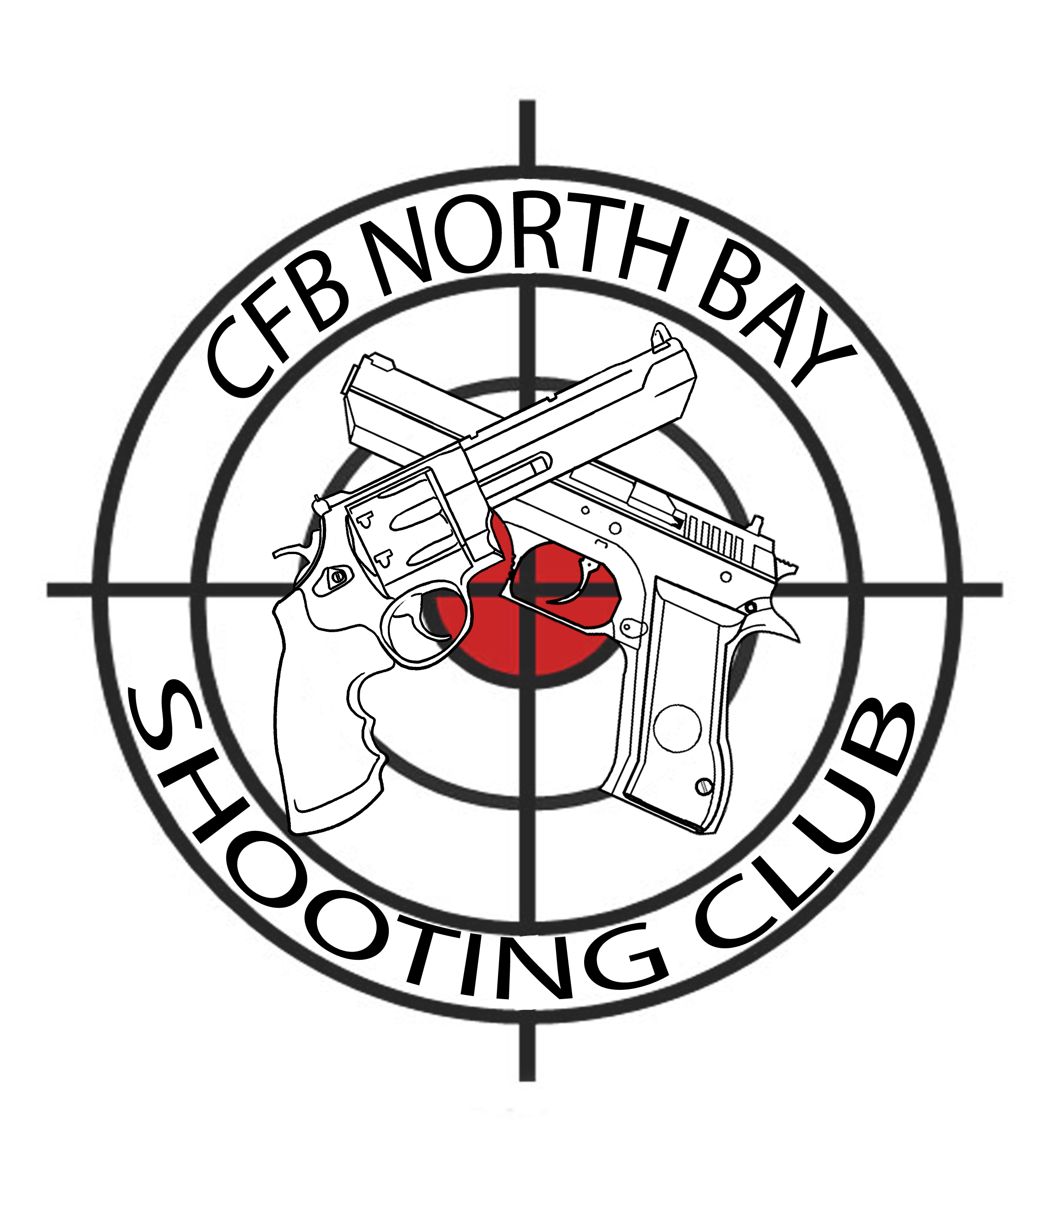
Membership Application

Date |  | Address
Name |  | City
Rank |  | Province
Home |  | PAL #
Work |  | Expiry
Cell |  | Class | ◻PAL | ◻RPAL | ◻12.x
Email

Annual Membership Dues
Regular Member | $30.00 ◻  
Ordinary Member | $35.00 ◻  
Associate Member | $40.00 ◻  

References:

1. Name:_______________________________ Telephone: __________________

2. Name:_______________________________ Telephone: __________________

Media Release Consent:

From time to time, still pictures and/or video may be taken of club activities. These pictures and video may be released by the club to the public, including posting on social media. Pictures and video of you engaged in club activities will not be released without your consent. You may revoke your consent at any time by notifying a club executive.

◻ I consent to the club releasing pictures and video of me engaging in club activities to the public
◻ I do not consent to the club releasing pictures and video of me engaging in club activities to the public

Agreement of Terms:

As a member of the CFB North Bay Shooting Club, I agree that I will abide by all pertinent regulations in effect, including but not limited to CFMWS Recreation Activity Regulations, National Directives, Wing Standing Orders, Range Safety Orders, and Club Constitution and By-laws. I agree that the duty Range Safety Officer is in charge of all shooting activities, and I will follow their instructions while at the range. I further agree that failure to abide by regulations or instructions may result in expulsion from the club, administrative and/or disciplinary action, and/or criminal charges.

Member’s Signature: __________________________________________

Club Use Only:

Membership date: ________________ Dues Paid: __________________

